# **Accessing your COMP1835 VM**

**Step 1**. If you are accessing your COMP1835 VM from any King William (KW) labs, skip to the **step 2**, otherwise, if you accessing your VM from home or from the University’s library, **you need to login to Virtual Desktop first:**

# **Accessing the Virtual Desktop**

You can access the Virtual Desktop system by installing the VMware Horizon client or by using the web interface.

Please note the Virtual Desktop system is only available to students in the School of Computing and Mathematical Sciences who study at the Maritime Greenwich campus.

### **Using the VMware Horizon client**

If you are using a PC at the University, the VMware Horizon client will be available for install from [Software Center](mailto:https://docs.gre.ac.uk/rep/information-and-library-services/installing-additional-software-available-from-the-software-center) if there is no shortcut for it on the Start Menu.

On your own devices you can download and install the VMware Horizon client by browsing to [**https://studentdesktop.gre.ac.uk**](https://studentdesktop.gre.ac.uk/)and clicking on the **Install VMware Horizon Client**link. This will take you to a page where you can download the client for your device / operating system.

Once you have installed the client you need to create a new connection to **studentdesktop.gre.ac.uk**:

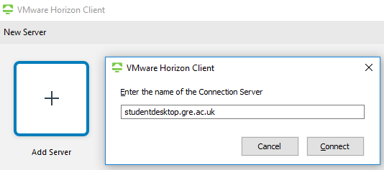

And then login with your University username and password. Note you need to login as [username@gre.ac.uk](mailto:username@gre.ac.uk) to be able to access the system.

### **Using the web interface:**

To access a virtual desktop using the web interface browse to <https://studentdesktop.gre.ac.uk/portal/webclient/index.html> in a web browser and then login with your University username and password.

You will need to login as [username@gre.ac.uk](mailto:username@gre.ac.uk) to be able to access the system.  
  
Please also note that we recommend that you use the VMware Horizon client if possible to get the best possible performance.

**Step 2.**

1.To access the COMP1835 VM open a web browser (we recommend you use Google Chrome however Microsoft Edge or Internet Explorer can be used too). If you are using Virtual Desktop, make sure you **open Browser inside Virtual Desktop**.

and navigate to the URL  
  
<https://classroom-vc.gre.ac.uk/ui>  
  
And login with your University username and password when prompted (staff users will need to put staff\their-username as the username).

### 2. Once you have logged in, click on the “>” next to “CLASSROOM” and then the “>” next to “ACH_Classroom” in the left hand pane to see the VMs that you have access to:

Note that the number of VMs you see will depend on which courses you are enrolled on.

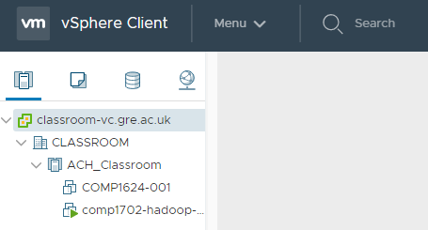

VMs that are powered on will have a green arrow pointing right to indicate this – in the above example the “COMP1624-001” VM is powered off and the VM starting “comp1702” is powered on.

To power on a VM, select it in the left hand pane, and then right click on it, and from the menu that appears click “Power” -> “Power On”:

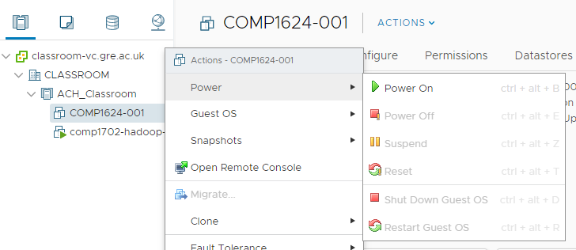

### 3. Using your Virtual Machines

Note: For the best experience when using your VMs we’d recommend that you open the console in the VMware Remote Console (VMRC), using link **Launch Remote Console**

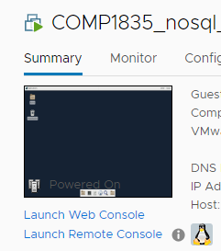

The VMRC will already be installed on the Remote Desktop, and in the Faculty labs in King William.

To access the console of your VM select the “Launch Remote Console” option. Depending on which browser you are using, you may be prompted to confirm you want to open the VMRC – say yes / open when prompted.

The VMRC will now launch and you can access the console of your VM from it. The VMRC menu gives options for sending Ctrl-Alt-Del, powering on the VM etc.

If you have any problems with Remote Console, you can use **Web Console**, by clicking on the link **Launch Web Console**, which will open your Console in the new tab of your Browser.

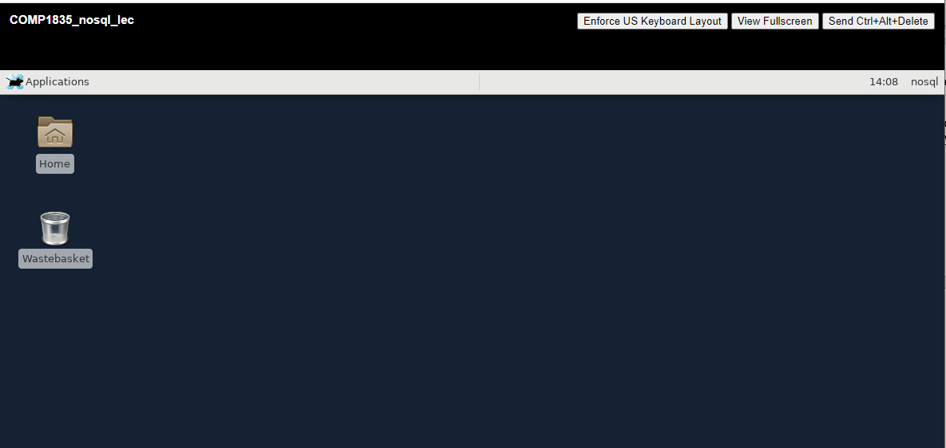

### 4. Help with the Classroom Environment

If you have any problems with the tutorials or coursework that you need to use your VMs for you should speak to your lecturer in the first instance.

If you have any problems using the Classroom Environment, can’t access VMs you should be able to or have a general question about the Classroom Environment please contact [FLAS_Systems@gre.ac.uk](mailto:FLAS_Systems@gre.ac.uk).

Please ensure you include your University username, what course you are studying, which VMs you are having trouble with and information on any error message(s) you are getting (include screenshots if possible) as this will allow us to investigate your problem quicker.